Ansible Task 2
- Watch ansible-02 video and write down notes.
- Install httpd using ansible playbook, use handlers,notifiers.
- Write a ansible playbook to provision one ec2 on aws.
- Write a ansible playbook to copy one file from node-1 to node-2.
- Write a ansible playbook to install apache tomcat.
- Write a ansible playbook to create different files with different names using single playbook.

Ansible Playbooks — Notes
1. What is Ansible?
Ansible is an open-source automation tool used to configure servers, install software, deploy applications, and automate repetitive IT tasks.
Main uses:
- Configuration management
- Application deployment
- Software installation
- Server provisioning
- Task automation
2. Ansible Architecture
Control Node: The machine where Ansible is installed and playbooks are executed.
Managed Nodes: The remote servers managed by Ansible.
Inventory: A file containing managed server IP addresses and connection details.
SSH: Used to connect to Linux managed nodes.
Modules: Perform tasks such as installing packages, copying files, and managing services.
3. What is an Ansible Playbook?
An Ansible playbook is a YAML file containing instructions to automate tasks on one or more managed nodes.
Playbooks commonly use the .yml or .yaml extension.
Example:
---
- name: Install Apache web server
hosts: workers
become: true

tasks:
- name: Install Apache
ansible.builtin.apt:
name: apache2
state: present
update_cache: true
Explanation:
- --- — Marks the beginning of a YAML document.
- name — Describes the play or task.
- hosts — Specifies the target group from the inventory.
- become: true — Runs tasks with elevated privileges.
- tasks — Contains the operations to execute.
- ansible.builtin.apt — Manages packages on Debian/Ubuntu systems.
- state: present — Ensures the package is installed.
Note: On Amazon Linux or RHEL, use the appropriate package manager, such as ansible.builtin.dnf.
4. Important Ansible Modules
Module | Purpose
ansible.builtin.apt | Install or remove packages on Debian/Ubuntu
ansible.builtin.dnf | Manage packages on supported RPM-based systems
ansible.builtin.service | Manage services
ansible.builtin.copy | Copy files to managed nodes
ansible.builtin.file | Create files/directories and manage permissions
ansible.builtin.template | Deploy files using Jinja2 templates
ansible.builtin.command | Execute commands
ansible.builtin.user | Manage user accounts
ansible.builtin.debug | Display messages and variable values
5. Inventory File
The inventory identifies the servers on which playbooks will run.
Example:
[workers]
worker1 ansible_host=WORKER1_PRIVATE_IP
worker2 ansible_host=WORKER2_PRIVATE_IP

[workers:vars]
ansible_user=ansadm
ansible_python_interpreter=/usr/bin/python3
Replace the placeholder IP addresses with your actual worker private IPs.
Test connectivity:
ansible workers -i inventory -m ping
Expected result: Both workers should return SUCCESS with "ping": "pong".
6. How to Execute a Playbook
Create a playbook:
nano install-apache.yml
Run the playbook:
ansible-playbook -i inventory install-apache.yml
Check the result:
ansible workers -i inventory -m ping
Common execution options:
ansible-playbook --syntax-check install-apache.yml
ansible-playbook -i inventory install-apache.yml --check
The syntax check validates the playbook structure. Check mode simulates supported changes, but not every module supports full simulation.
7. Handlers and Notify
A handler is a special task that runs only when notified by a task that reports a change.
Example:
---
- name: Configure Apache
hosts: workers
become: true

tasks:
- name: Install Apache
ansible.builtin.apt:
name: apache2
state: present
update_cache: true

- name: Update Apache configuration
ansible.builtin.copy:
content: "ServerName localhost\n"
dest: /etc/apache2/conf-available/servername.conf
notify: Restart Apache

handlers:
- name: Restart Apache
ansible.builtin.service:
name: apache2
state: restarted
Important points:
- notify triggers a handler when the associated task changes something.
- The handler name must match the notification name.
- Handlers normally run at the end of the play.
- Multiple notifications for the same handler are generally consolidated into one execution per play.
- If a task makes no change, its handler is not triggered.
8. Loops in Ansible
Loops allow us to repeat a task for multiple values without writing the same task repeatedly.
Example:
---
- name: Create multiple files
hosts: workers
become: true

tasks:
- name: Create files
ansible.builtin.file:
path: "/tmp/{{ item }}"
state: touch
loop:
- file1.txt
- file2.txt
- file3.txt
This playbook creates three files using one task.
9. Variables
Variables allow us to reuse values and customize playbooks.
Example:
---
- name: Install a package
hosts: workers
become: true

vars:
package_name: apache2

tasks:
- name: Install package
ansible.builtin.apt:
name: "{{ package_name }}"
state: present
The {{ package_name }} expression references the variable value.
10. Idempotency
Idempotency means running a playbook repeatedly should leave the system in the desired state without making unnecessary changes.
For example, using state: present ensures a package is installed rather than reinstalling it every time.
11. Ansible Playbook Workflow
- Create an inventory file.
- Verify connectivity to managed nodes.
- Write the YAML playbook.
- Check YAML indentation and syntax.
- Run the playbook.
- Review the output for failures or changes.
- Verify the application, file, or service on the managed node.
12. Summary
- Ansible automates server administration.
- Playbooks define tasks in YAML.
- Inventory specifies target servers.
- Modules perform the actual operations.
- Handlers run in response to notifications.
- Loops repeat tasks for multiple values.
- Variables make playbooks reusable.
- Idempotency helps avoid unnecessary changes.
- Always validate and verify playbook execution.

2. Install httpd using an Ansible playbook; use handlers, notifiers.
Step 1: Create the playbook
Run this command on your Ansible master:
cd ~/ansible-lab
Now create the complete playbook:
cat > install_httpd.yml <<'EOF'
---
- name: Install Apache using Ansible
hosts: workers
become: true

tasks:
- name: Install Apache web server
ansible.builtin.apt:
name: apache2
state: present
update_cache: true

- name: Create a sample web page
ansible.builtin.copy:
content: |
<html>
<body>
<h1>Apache installed using Ansible Playbook!</h1>
</body>
</html>
dest: /var/www/html/index.html
owner: root
group: root
mode: '0644'
notify: Restart Apache

- name: Ensure Apache is enabled and running
ansible.builtin.service:
name: apache2
state: started
enabled: true

handlers:
- name: Restart Apache
ansible.builtin.service:
name: apache2
state: restarted
EOF
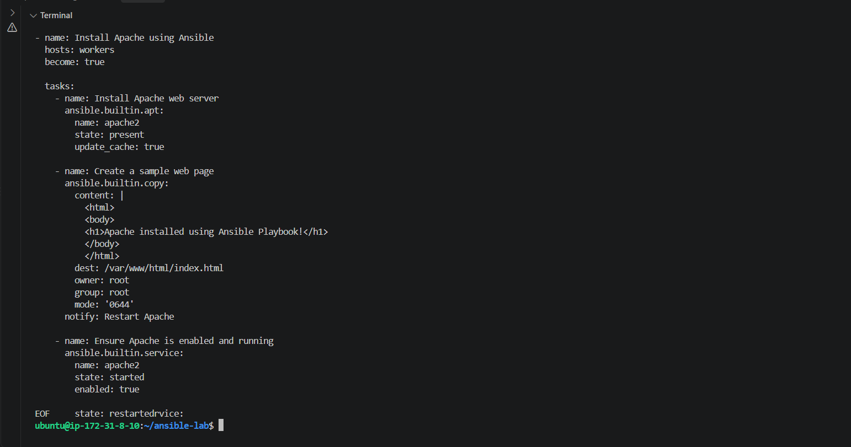
Step 2: Run the playbook
ansible-playbook -i ansible_hosts install_httpd.yml
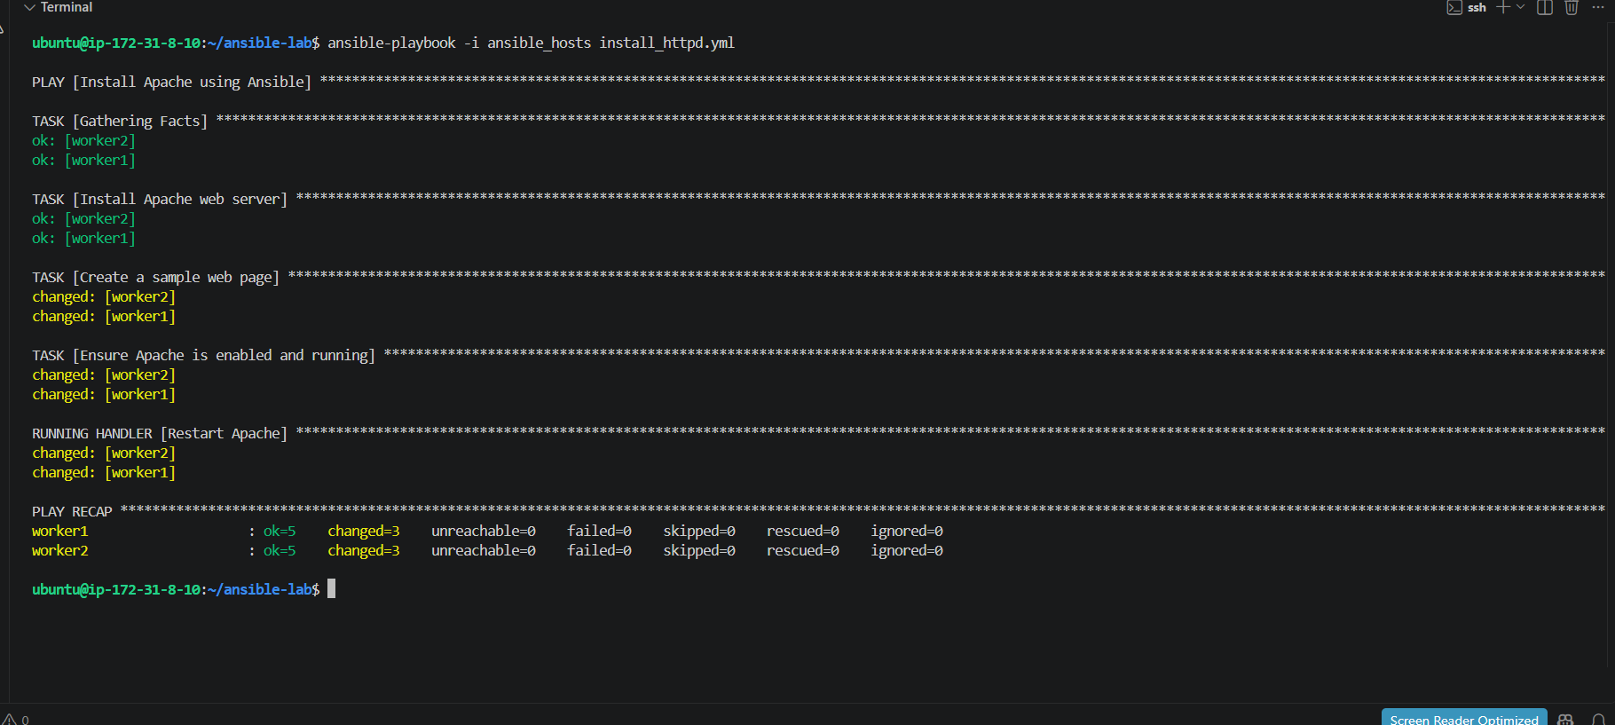
Step 3: Verify the result
After the playbook finishes, run:
ansible workers -i ansible_hosts -m command -a "systemctl is-active apache2"
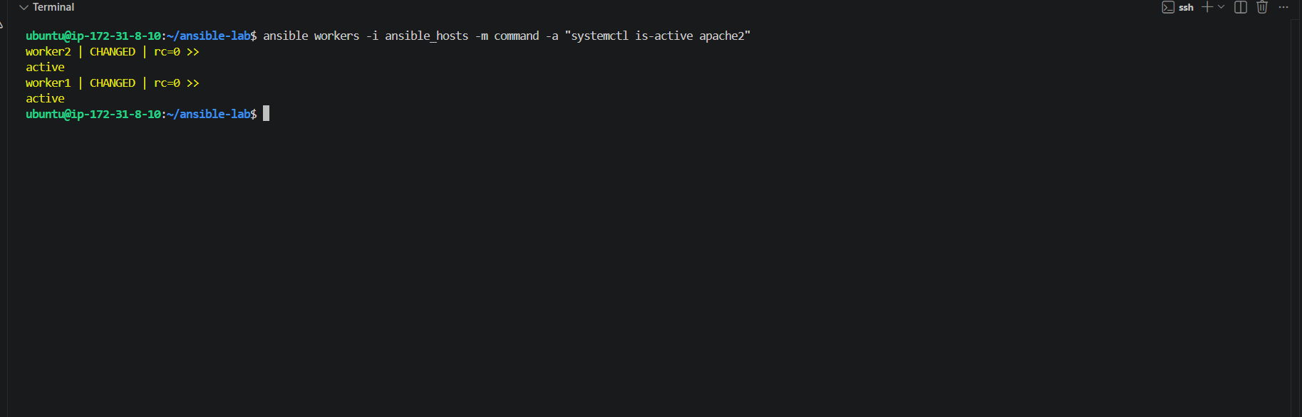
Apache is now active on both worker nodes.
This confirms the service is running, but let's also verify that the playbook used the handler correctly.
Step 1: Check the playbook output
Did ansible-playbook -i ansible_hosts install_httpd.yml complete successfully? If yes, look for a line similar to:
RUNNING HANDLER [Restart Apache]
The handler should run if the web page changed and notified it.
Step 2: Verify the web page
Run this command on your Ansible master:
ansible workers -i ansible_hosts -m command -a "curl -s http://localhost"
This runs curl on each worker to check its local Apache page.
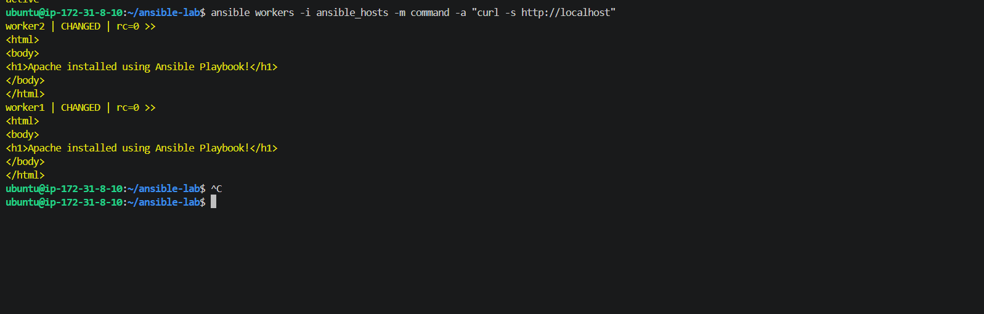
Task 2: Install Apache Tomcat using an Ansible Playbook
We'll do this step by step on your existing Ansible master.
Step 1 — Create the playbook file
Run this command on your Ansible master:
cd ~/ansible-lab
nano install_tomcat.yml
Now paste this complete playbook into nano:
---
- name: Install Apache Tomcat on workers
hosts: workers
become: true

tasks:
- name: Update apt cache
ansible.builtin.apt:
update_cache: true
cache_valid_time: 3600

- name: Install Java
ansible.builtin.apt:
name: default-jdk
state: present

- name: Install Tomcat
ansible.builtin.apt:
name:
- tomcat10
- tomcat10-admin
state: present

- name: Ensure Tomcat is enabled and running
ansible.builtin.service:
name: tomcat10
state: started
enabled: true

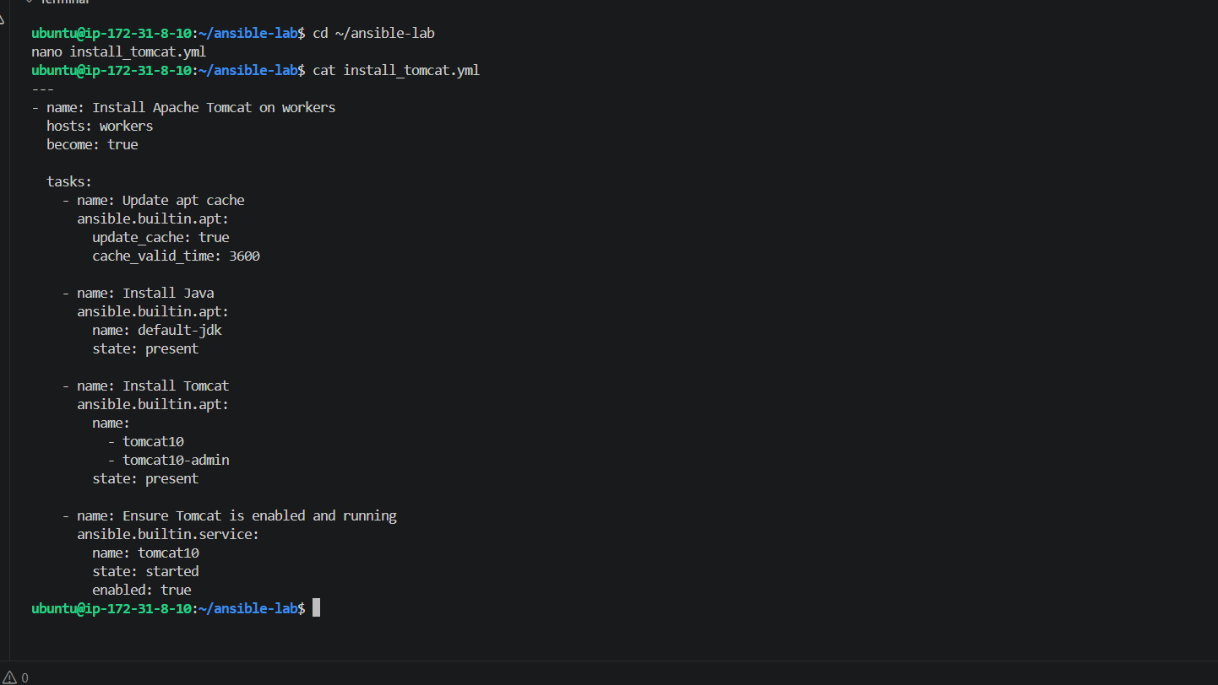
Next step: Run the playbook on your Ansible master:
ansible-playbook -i ansible_hosts install_tomcat.yml
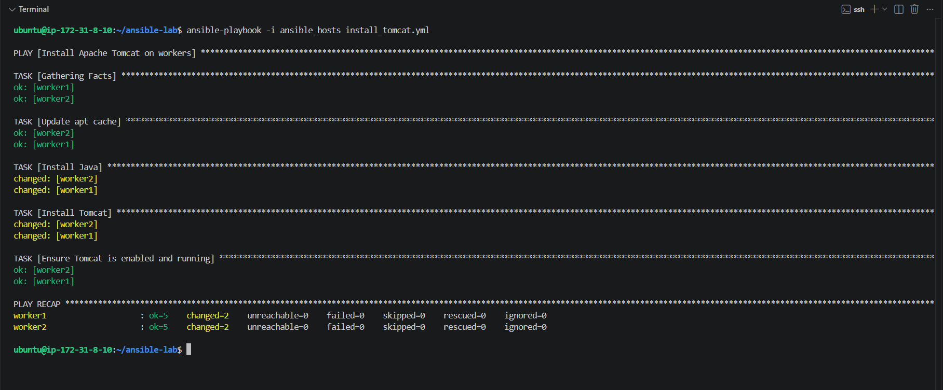
Apache Tomcat installation is successful before moving to Task 3.
Run this command on your Ansible master:
ansible workers -i ansible_hosts -m command -a "systemctl is-active tomcat10"

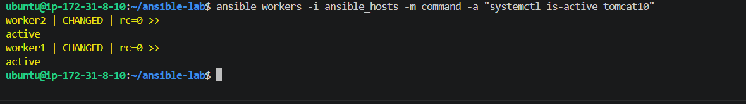

Task 3 — Provision an EC2 instance
We'll create a playbook that launches one Ubuntu EC2 instance in your AWS region, ap-south-1 (Mumbai).
Before launching it, we'll check the available Ubuntu AMI and your default VPC/subnets so the playbook uses valid AWS resources.
Step 1 — Check the default VPC
Run this command on your Ansible master:
aws ec2 describe-vpcs \
--region ap-south-1 \
--filters "Name=isDefault,Values=true" \
--query "Vpcs[].VpcId" \
--output text
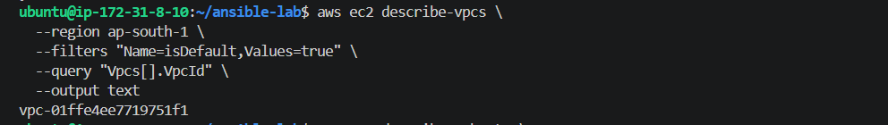
Step 2 — Find a subnet in that VPC
Run this command on your Ansible master:
aws ec2 describe-subnets \
--region ap-south-1 \
--filters "Name=vpc-id,Values=vpc-01ffe4ee7719751f1" \
--query "Subnets[].{SubnetId:SubnetId,AZ:AvailabilityZone,PublicIP:MapPublicIpOnLaunch}" \
--output table
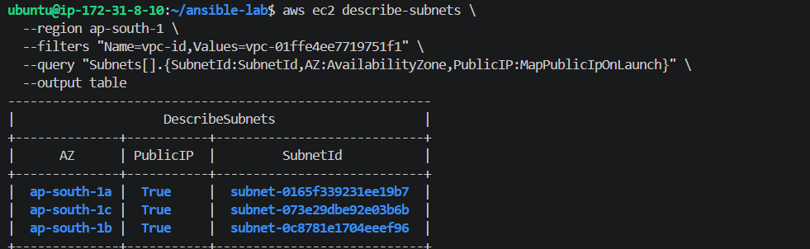
Step 3 — Find an Ubuntu AMI
Run this command on your Ansible master to find the latest Ubuntu 24.04 LTS AMI published by Canonical:
aws ssm get-parameter \
--region ap-south-1 \
--name /aws/service/canonical/ubuntu/server/24.04/stable/current/amd64/hvm/ebs-gp3/ami-id \
--query "Parameter.Value" \
--output text
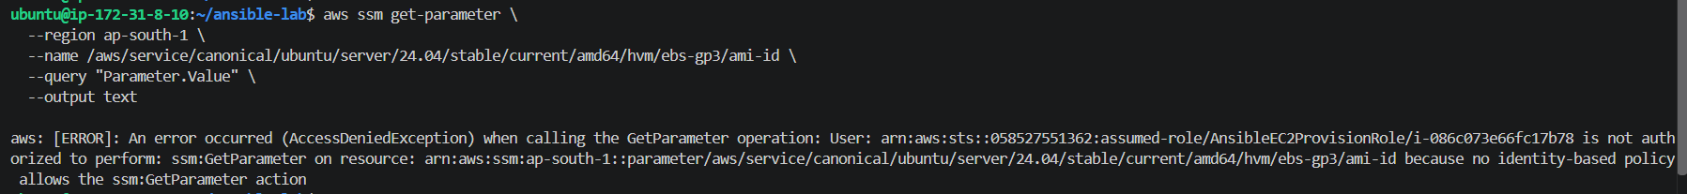
Step 3 — Find the Ubuntu 24.04 AMI
Run this command on your Ansible master:
aws ec2 describe-images \
--region ap-south-1 \
--owners 099720109477 \
--filters "Name=name,Values=ubuntu/images/hvm-ssd-gp3/ubuntu-noble-24.04-amd64-server-*" \
"Name=state,Values=available" \
--query "sort_by(Images,&CreationDate)[-1].[ImageId,Name]" \
--output table
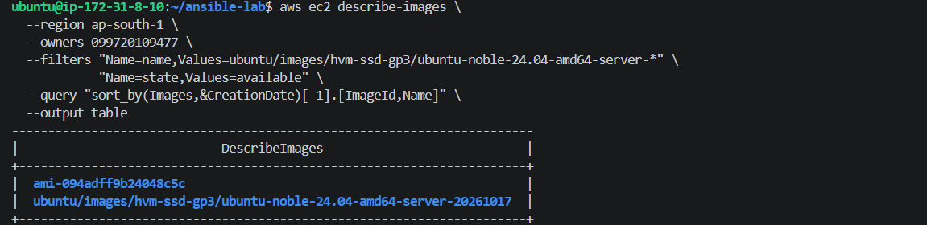
Step 4 — Check your EC2 key pair
Before creating the playbook, let's check which key pairs are available. This lets you SSH into the new instance later if needed.
Run:
aws ec2 describe-key-pairs \
--region ap-south-1 \
--query "KeyPairs[].KeyName" \
--output table
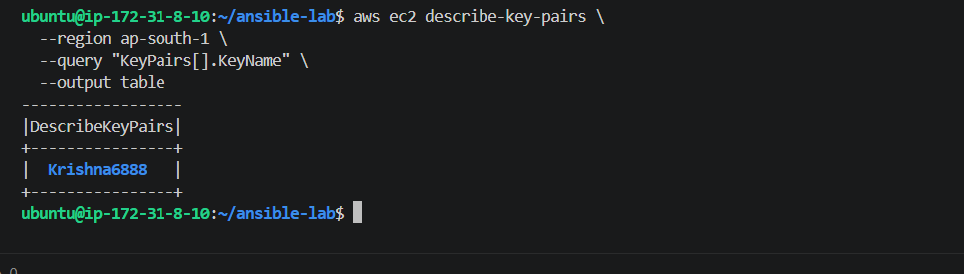
Step 5 — Create the EC2 provisioning playbook
Create the file:
cd ~/ansible-lab
nano provision_ec2.yml
Paste this complete playbook:
---
- name: Provision an EC2 instance on AWS
hosts: localhost
connection: local
gather_facts: false

vars:
aws_region: ap-south-1
ami_id: ami-094adff9b24048c5c
instance_type: t3.micro
key_name: Krishna6888
subnet_id: subnet-0165f339231ee19b7

tasks:
- name: Launch one Ubuntu EC2 instance
amazon.aws.ec2_instance:
name: Ansible-Provisioned-EC2
region: "{{ aws_region }}"
image_id: "{{ ami_id }}"
instance_type: "{{ instance_type }}"
key_name: "{{ key_name }}"
vpc_subnet_id: "{{ subnet_id }}"
count: 1
network:
assign_public_ip: true
wait: true
state: running
register: ec2_result

- name: Display the created instance details
ansible.builtin.debug:
msg: >-
Instance ID: {{ ec2_result.instances[0].instance_id }},
Private IP: {{ ec2_result.instances[0].private_ip_address }},
Public IP: {{ ec2_result.instances[0].public_ip_address | default('Not assigned') }}
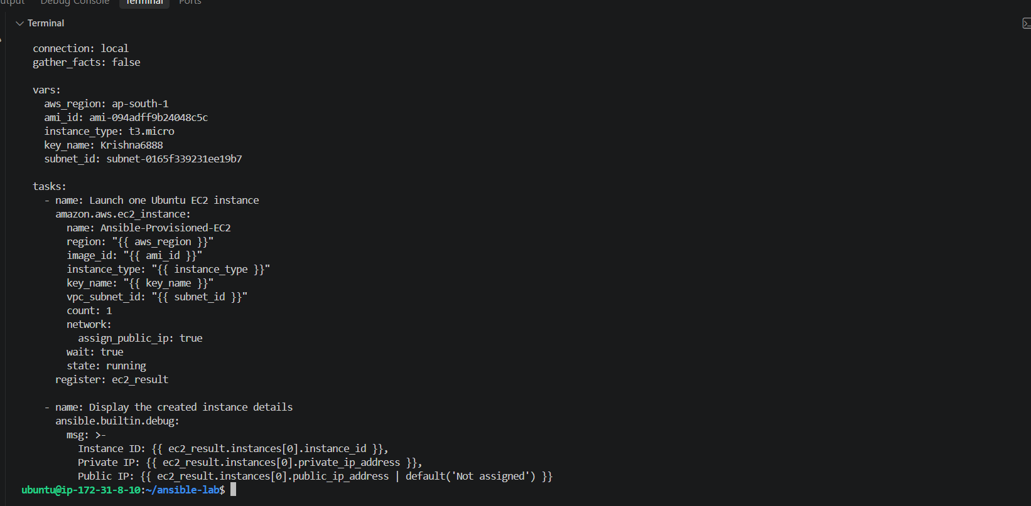
Step 6 — Install the AWS Ansible collection
Run this command on your Ansible master:
ansible-galaxy collection install amazon.aws
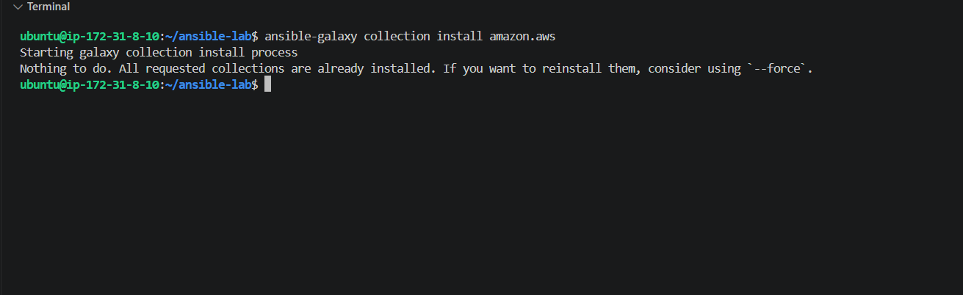
Step 7 — Install boto3
Run this command on your Ansible master:
python3 -m pip install --user boto3
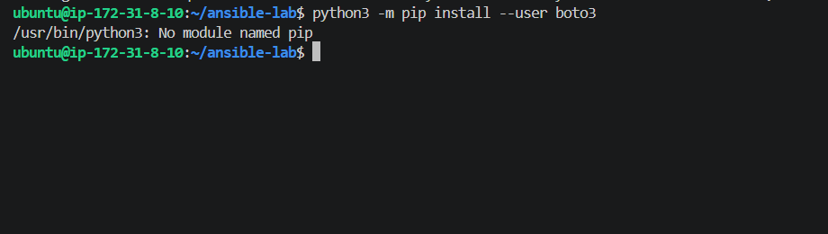
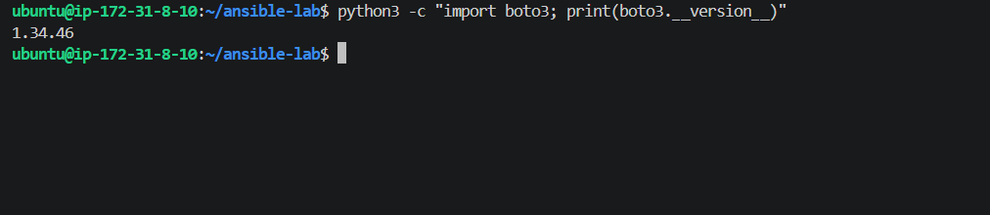
Step 8 — Validate the playbook
Run this command:
cd ~/ansible-lab
ansible-playbook --syntax-check provision_ec2.yml
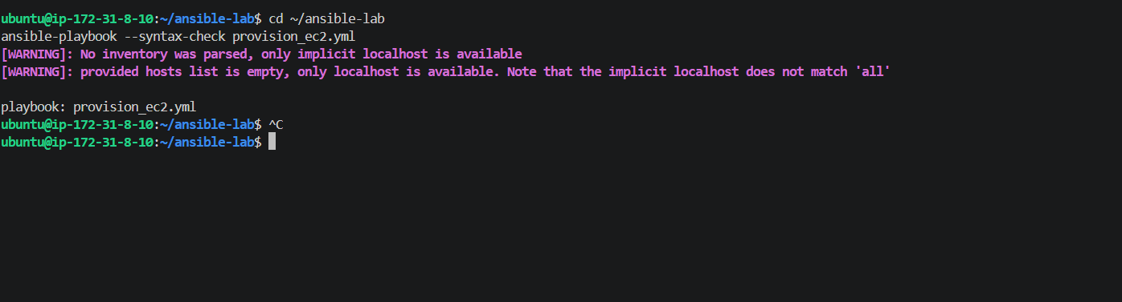
Step 9 — Launch the EC2 instance
Before running it, remember that launching an EC2 instance can incur AWS charges.
Run:
ansible-playbook provision_ec2.yml
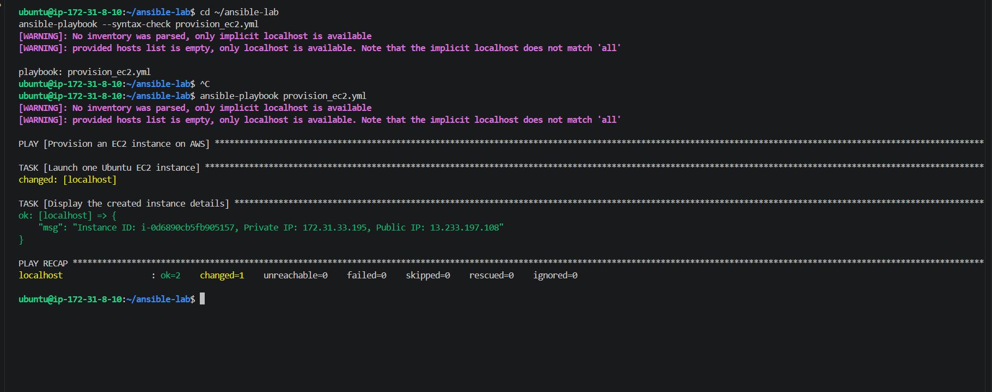
Task 4 — Copy a file from node-1 to node-2
We'll create a file on worker1 and copy it to worker2 using an Ansible playbook.
Step 1 — Create the source file on worker1
Run this command on your Ansible master:
ansible worker1 -i ansible_hosts -m copy -a "content='Hello from worker1! Copied using Ansible.' dest=/tmp/node1-fil
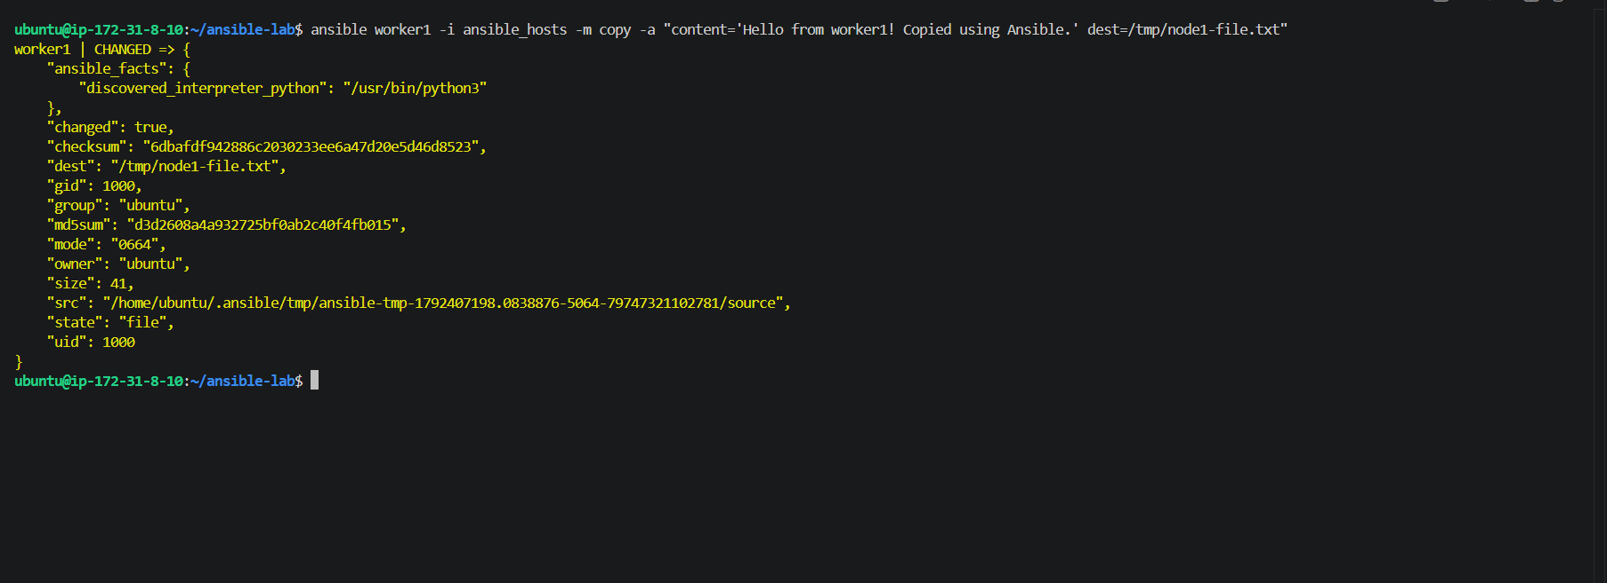
Step 2: Create the copy playbook
We'll use Ansible's fetch module to copy the file from worker1 to the Ansible master, then copy to transfer it to worker2.
Open a new playbook:
nano copy_file_between_nodes.yml
Paste this complete code:
---
- name: Copy file from worker1 to worker2
hosts: localhost
connection: local
gather_facts: false

tasks:
- name: Fetch file from worker1 to Ansible master
ansible.builtin.fetch:
src: /tmp/node1-file.txt
dest: /tmp/node1-file.txt
flat: true
delegate_to: worker1

- name: Copy file from Ansible master to worker2
ansible.builtin.copy:
src: /tmp/node1-file.txt
dest: /tmp/node1-file.txt
mode: '0644'
delegate_to: worker2
Step 3 — Execute the playbook
Run this command on your Ansible master:
ansible-playbook -i ansible_hosts copy_file_between_nodes.yml
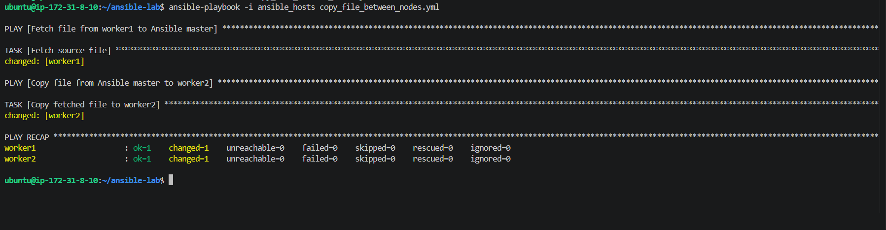
Step 1 — Verify the file on worker2
Run this command:
ansible worker2 -i ansible_hosts -m command -a "cat /tmp/node1-file.txt"
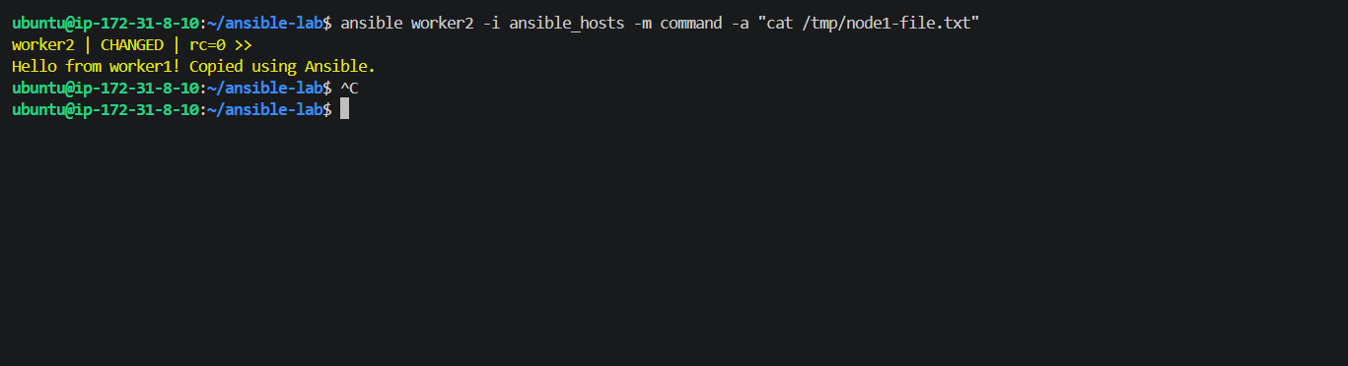
Task 5 — Create multiple files using a single Ansible playbook
We'll create three files with different names and contents on both workers using an Ansible loop.
Step 1 — Create the playbook
Run:
nano ~/ansible-lab/create_multiple_files.yml
Paste this complete playbook:
---
- name: Create multiple files on workers
hosts: workers
become: true
gather_facts: false

tasks:
- name: Create files with different names and contents
ansible.builtin.copy:
dest: "{{ item.path }}"
content: "{{ item.content }}\n"
owner: ubuntu
group: ubuntu
mode: '0644'
loop:
- path: /tmp/file1.txt
content: "This is file one"
- path: /tmp/file2.txt
content: "This is file two"
- path: /tmp/file3.txt
content: "This is file three"
Step 2 — Run the playbook
cd ~/ansible-lab
ansible-playbook -i ansible_hosts create_multiple_files.yml
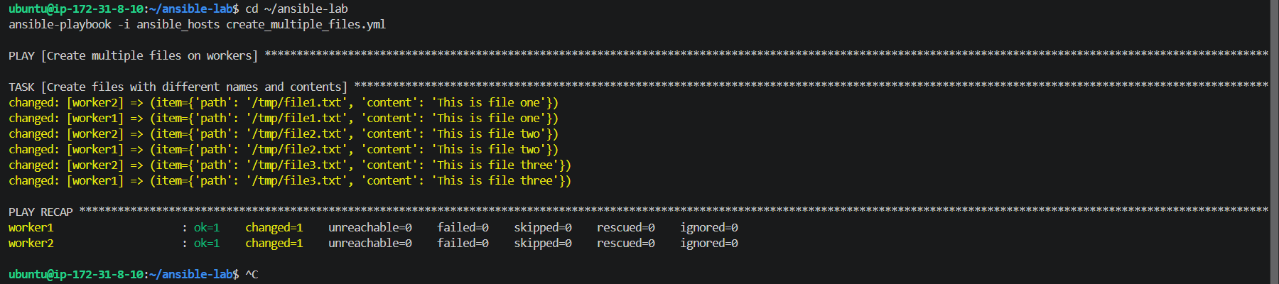
All three files were created on worker1 and worker2, with no failures.
Final verification
Run this command to verify the file names and contents on both workers:
ansible workers -i ansible_hosts -m shell -a "for f in /tmp/file1.txt /tmp/file2.txt /tmp/file3.txt; do echo ===
